Machine Description | A deliberately vulnerable lab machine for practicing web app exploits, privilege escalation, and post-exploitation to gain user and root access.
Target IP | 192.168.0.114
Vulnerability Name | • Weak Apache Tomcat Credentials & Misconfiguration  • Arbitrary File Upload Leading to Remote Code Execution  • Privilege Escalation via Insecure Backup Script
Port / Service | TCP 8080 / http
Severity | High 7.4
Attack Vetor | CVSS:3.0/AV:L/AC:H/PR:N/UI:N/S:U/C:H/I:H/A:H
Proof of Concept (PoC) | STEP 1 – Nmap to find the IP of the target machine.  STEP 2 – Nmap Scan to discover open ports and Services  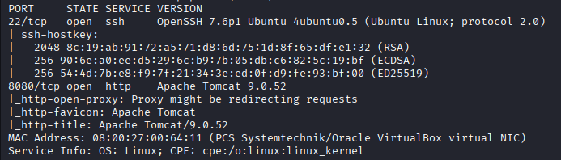  # nmap –p- -sC –sV $ip –open  STEP 3 - Found a Tomcat login page  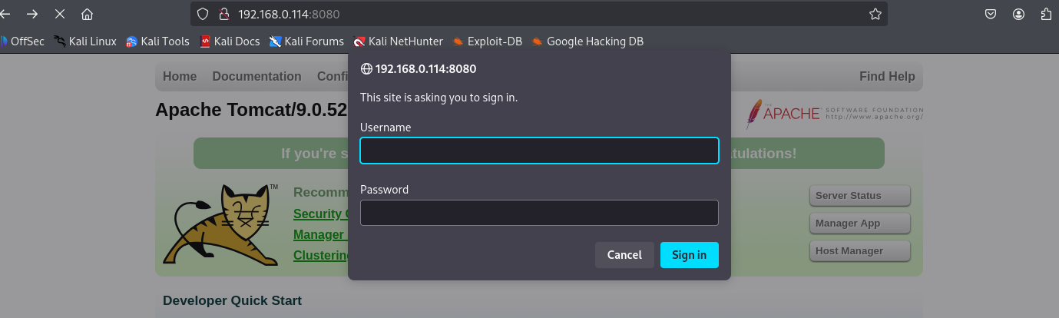  STEP 4 - We cannot brute force it using hydra as Tomcat encodes the data before sending and hydra don’t, found a module in metasploit  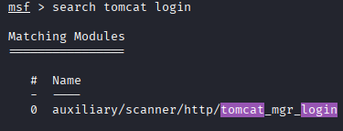  STEP 5 - Found a cred  STEP 6 -We loggen in as Host Manager  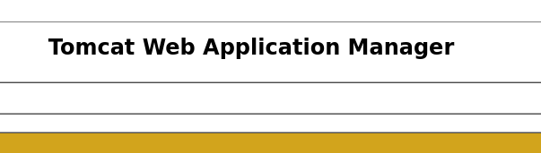  STEP 7 –We Can upload .war file  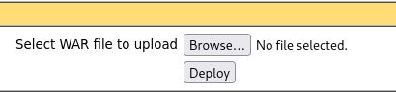  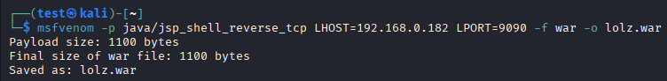  STEP 8 - Created a Malware  STEP 9 -uploaded it  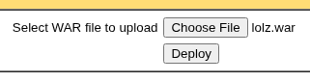  STEP 10 –Start a nc listener and clicked on the file  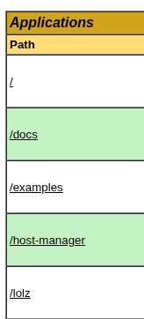  STEP 11 -Got Shell  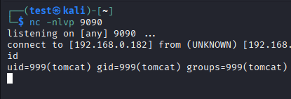  STEP 12 -Found a Script  STEP 13 - We Appended the backups.sh file with:  #echo “cp /bin/dash /var/tmp/dash ; chmod u+s /var/tmp/dash” >> /usr/local/bin/hackup.sh  STEP 14 –We have to wait until the script runs, and we will have :  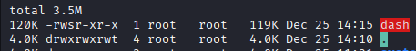  Step 15 – Ran it and will have ROOT:  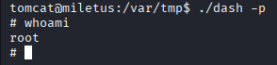
Remediation | • Change default and weak Tomcat usernames and passwords  • Restrict access to Tomcat Manager and Host Manager  • Disable .war file uploads if not required  • Apply latest security patches for Apache Tomcat  • Review and secure backup scripts with proper permissions  • Remove SUID permissions from unnecessary files  • Run services with least privilege access
Impact | • Attackers can log in to the web server without authorization  • Malicious files can be uploaded, allowing full control of the system  • Unauthorized users can gain root (administrator) access  • Complete system takeover, data theft, or system damage  • High risk of malware infection and service disruption
References | https://tomcat.apache.org/security-howto.html  https://owasp.org/www-project-top-ten/  https://www.cisa.gov/privilege-escalation

